**Freshco Hypermarket**

Order Level Analysis:

* When we do orders distributed at slot and delivery levels we can see the top three areas with the highest number of orders. This area is Harlur, HSR Layout and ITI Layout in which HSR Layout stands out and has the highest number of orders across all slots. Also, we can see that the number of orders in the afternoon is higher for HSR Layout.

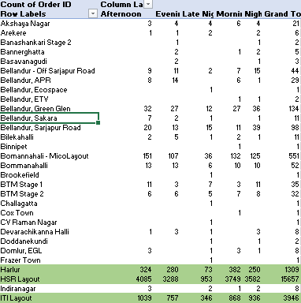

* HSR Layout has the highest increase in monthly orders in absolute orders. We can see that HSR Layout consistently have orders above 1000 from January to September. Hence, we can say that HSR Layout has the highest number of monthly orders.

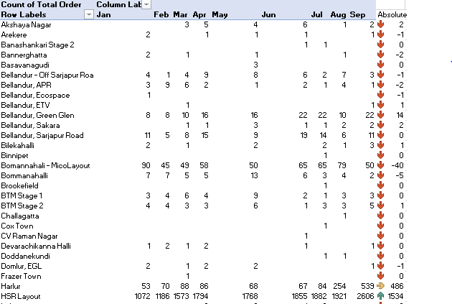

* Delivery %=Delivery charge/ Product Amount.
* The delivery percentage is higher during late-night deliveries.
* There is a noticeable decline in the delivery percentage across all slots from January to September.
* January recorded the highest delivery percentage across all slots, while September showed a decrease compared to the initial month.

|  |  |  |  |  |  |  |  |  |  |
| --- | --- | --- | --- | --- | --- | --- | --- | --- | --- |
| **Sum of Delivery %** | **Column Labels** | |  |  |  |  |  |  |  |
| **Row Labels** | **Jan** | **Feb** | **Mar** | **Apr** | **May** | **Jun** | **Jul** | **Aug** | **Sep** |
| Afternoon | 9% | 8% | 8% | 8% | 5% | 5% | 4% | 3% | 2% |
| Evening | 10% | 9% | 8% | 8% | 6% | 5% | 5% | 2% | 2% |
| Late Night | 16% | 17% | 16% | 16% | 4% | 13% | 13% | 8% | 6% |
| Morning | 11% | 10% | 9% | 8% | 5% | 5% | 5% | 3% | 2% |
| Night | 11% | 10% | 9% | 9% | 7% | 6% | 7% | 3% | 2% |

* Discount%= Discount/ Product Amount.

In August there are consistent discount % given to orders. From the graph comparing Discount % to slots and months we can see that August has the Highest Discount % though Late Nights has comparatively less compared to other slots. February has the lowest Discount % throughout the graph.

* From the line graph Late Night has the lowest Discount % at 4% and Night has the highest Discount % at 7%.

**Completion Rate Analysis:**

* When comparing the completion rate by slot and day of the week, Sunday stands out with a 100% completion rate across all slots.
* In contrast, Fridays and Tuesdays do not achieve a 100% completion rate.
* Overall, the completion rate falls short of 100% on several days, with more than two slots not reaching full completion.

|  |  |  |  |  |  |  |  |
| --- | --- | --- | --- | --- | --- | --- | --- |
| **Average of Completion Rate** | **Column Labels** |  |  |  |  |  |  |
| **Row Labels** | **Friday** | **Monday** | **Saturday** | **Sunday** | **Thursday** | **Tuesday** | **Wednesday** |
| Afternoon | 99% | 100% | 100% | 100% | 100% | 99% | 100% |
| Evening | 100% | 100% | 99% | 100% | 100% | 100% | 100% |
| Late Night | 99% | 99% | 100% | 100% | 100% | 99% | 100% |
| Morning | 99% | 100% | 100% | 100% | 99% | 100% | 99% |
| Night | 100% | 100% | 99% | 100% | 100% | 99% | 99% |

* **When we compare the completion rate with the drop area level we see a significant dip in three areas. Whitefield has the most dip in those areas with a 0% completion rate. The others are ETV and Cox Town with a 50% completion rate.**

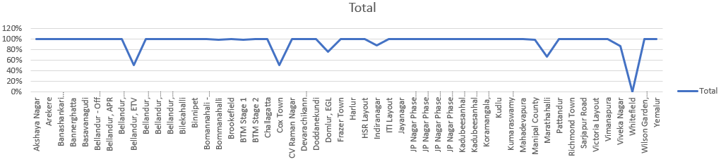

* **The Completion Rate is higher for the number of products 0 and 1 compared to the order level.**

**Customer Level Analysis:**

* **Comparing the completion rate at the source level reveals that the Organic source has the highest completion rate, while the Offline Campaign has the lowest.**
* **This indicates that customers acquired through the Organic source have fewer cancellations than those acquired through Offline Campaigns.**
* **The completion Rate can be lowest because the products have been cancelled or not received.**
* **When we calculate the Customer Lifetime Value we find that the highest amount spent by the customer is 62277 dollars. You can see the Fig below.**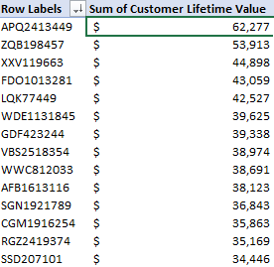
* **The Total LTV amount spent by each Acquisition source level is given in the table below. Here we can see that the highest amount spent is by Organic with 2 million dollars. The second highest is by Google.**

|  |  |
| --- | --- |
| **Row Labels** | **Sum of Customer Lifetime Value** |
| Facebook | $921,851 |
| Google | $1,939,010 |
| Instagram | $911,379 |
| Offline Campaign | $1,008,411 |
| Organic | $2,287,431 |
| Snapchat | $936,767 |
| **Grand Total** | **$8,004,849** |

* Comparing customer acquisition by month shows that January has the highest total LTV, exceeding 3 million dollars.
* However, there is a noticeable decline in total LTV in the months following January, indicating that customers acquired after January spent less.
* The total LTV for customers acquired in January is significantly higher compared to those acquired in September, highlighting a substantial difference.
* Customers acquired through Snapchat has the lowest average revenue when compared to the total number of orders.
* The average total orders exceeding 24 are rated the highest, with a rating of 5.
* Orders placed in the morning receive the highest ratings, with an average of 29 orders, compared to other time slots.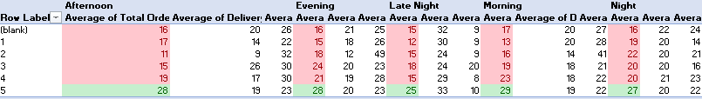

Delivery Level Analysis:

* In May, the average overall delivery time is the highest, with 43 minutes on weekdays and 48 minutes on weekends.
* March has the lowest average overall delivery time, with 19 minutes on both weekdays and weekends.
* The average overall delivery time for late-night deliveries is lower compared to other time slots.
* The Afternoon and Evening slots have the highest average overall delivery time, both at 26 minutes.
* In some delivery areas, average delivery charges at late night are higher compared to other slots within the same area.
* For example, in Brookefield, the average delivery charge is 332, with no other delivery slots available in that area.
* There are only four delivery areas with deliveries exclusively at late night, and these areas do not have deliveries in other time slots.

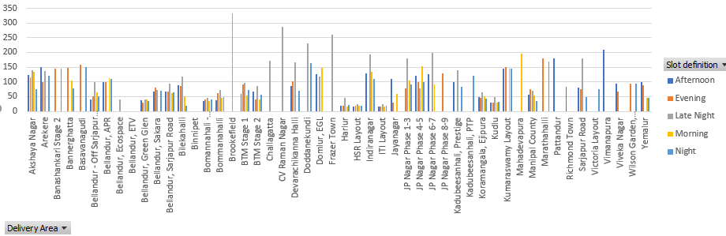

* The average delivery time for Cox Town is 3 minutes and for Whitefield is 1 minute. The shorter delivery times in these areas are due to incomplete deliveries.
* Mahadevapura has a comparatively higher delivery time because the deliveries in this area are completed.
* All these areas share a common factor: the number of orders delivered in each area is less than or equal to 1.